AI ASSISTED CODING

NAME: N. Akshitha
BATCH: 40
ROLL NO : 2303A52116

Lab 14: Web Design Application – AI-Assisted HTML/CSS/JS Generation Task 1 – Portfolio Website Design
You are building a personal portfolio website to showcase your work.
Requirements:
- Create sections for About Me, Projects, and Contact.
- Use AI to:
o Suggest color palettes and typography. o Create a responsive layout with Grid/Flexbox. o Add smooth scrolling navigation.
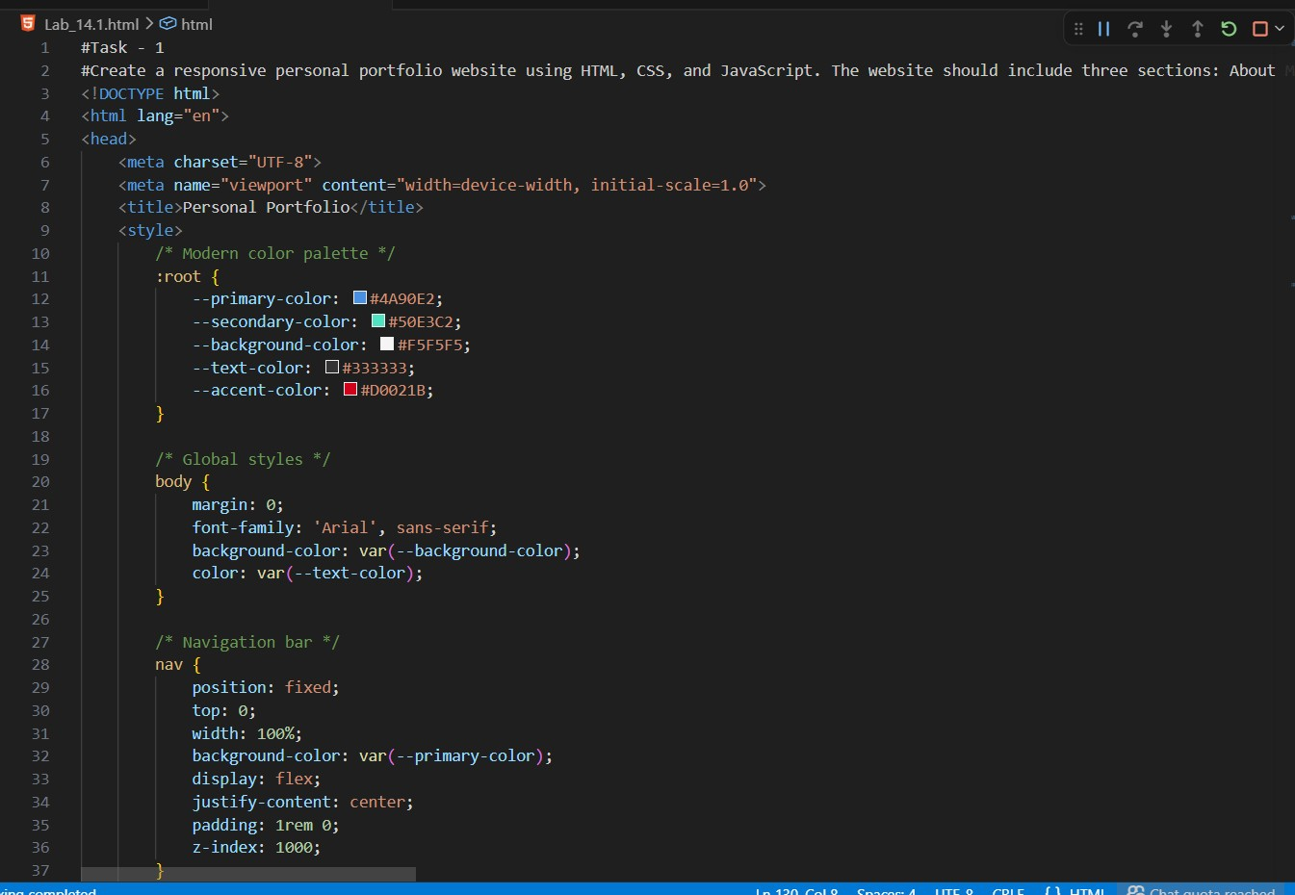
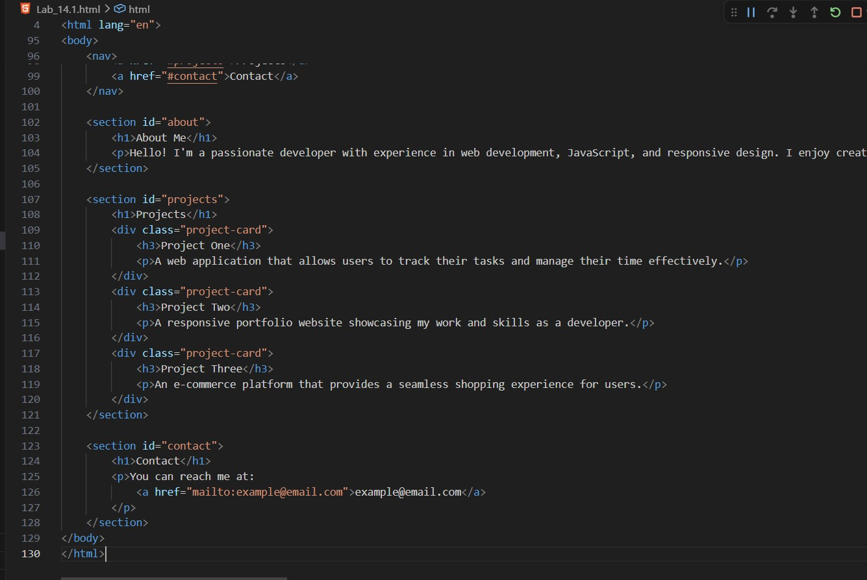
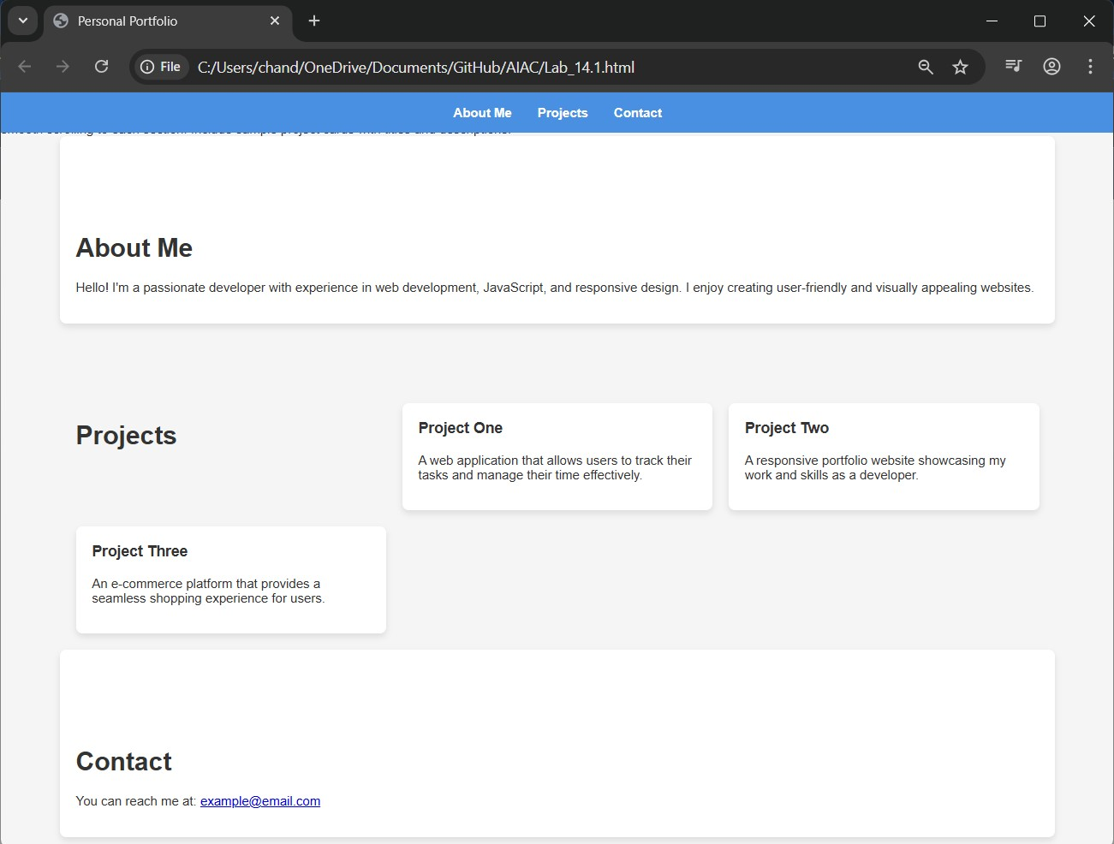

Task 2 – Online Store Product Page
Design a product display page for an online store.
Requirements:
- Display product image, title, price, and "Add to Cart" button.
- Use AI to:
- Style with BEM methodology.
- Make layout responsive. o Add hover effects and "Add to Cart" alert.
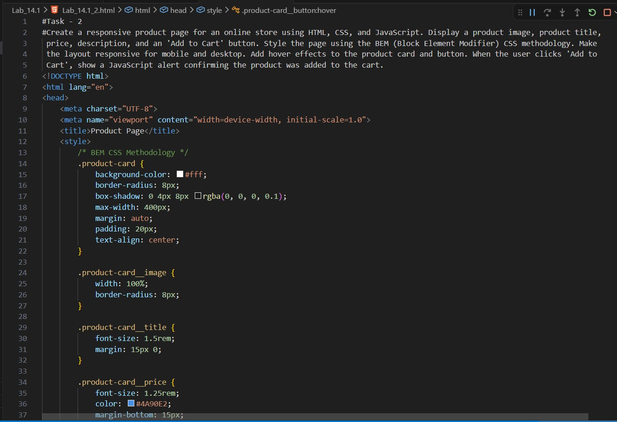
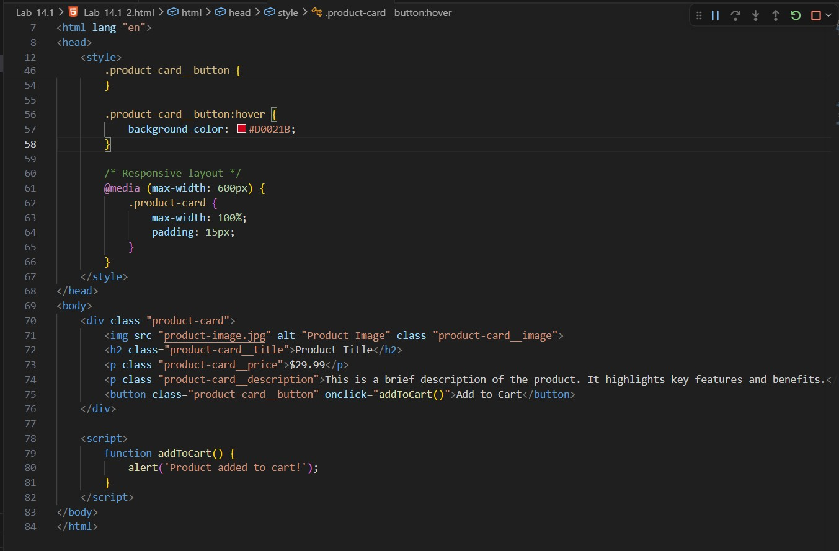
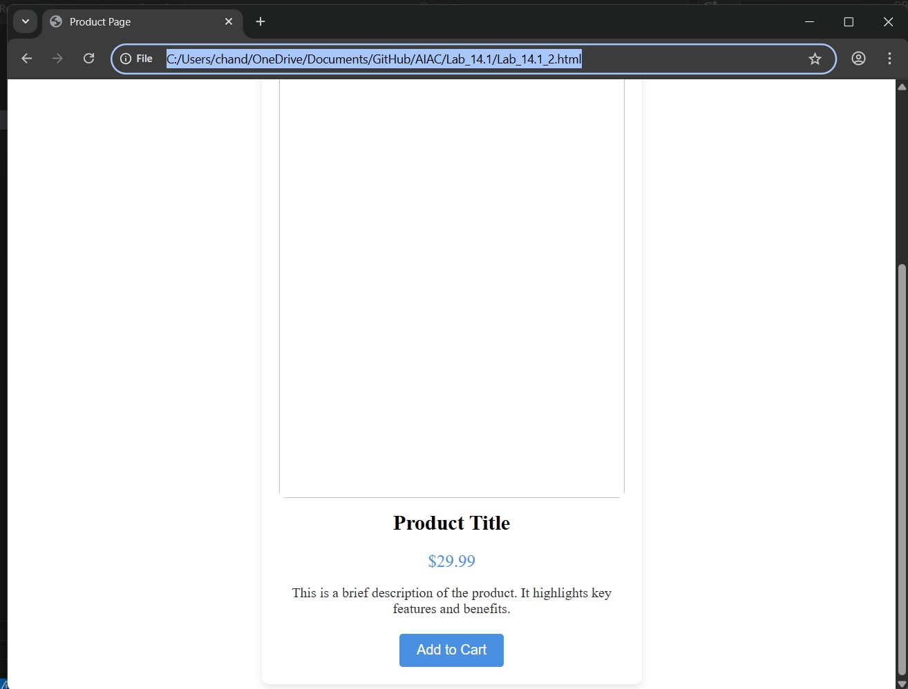

Task 3 – Event Registration Form
Build an event registration form for a conference.
Requirements:
- Collect name, email, phone number, and session selection.
- Use AI to:
- Add form validation with JavaScript.
- Make the form accessible with labels and ARIA. o Style with a professional look.
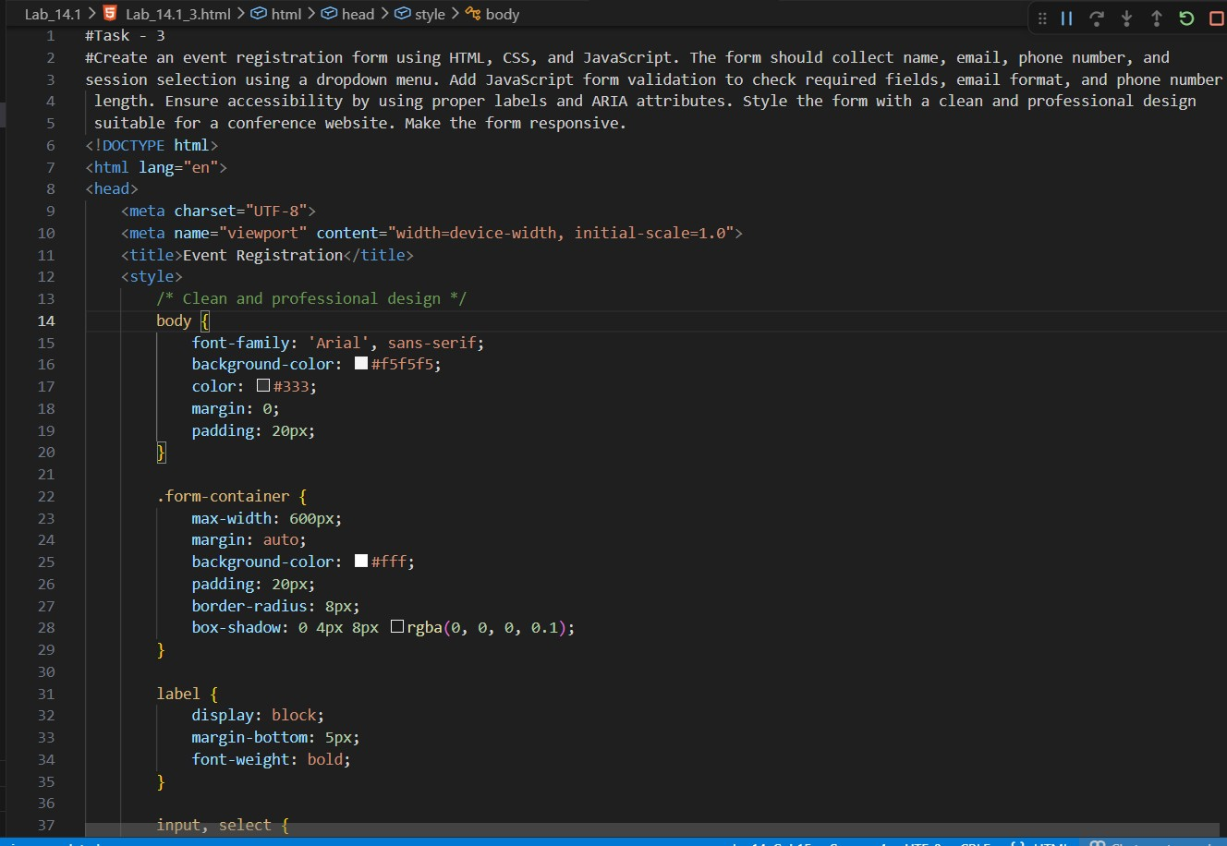
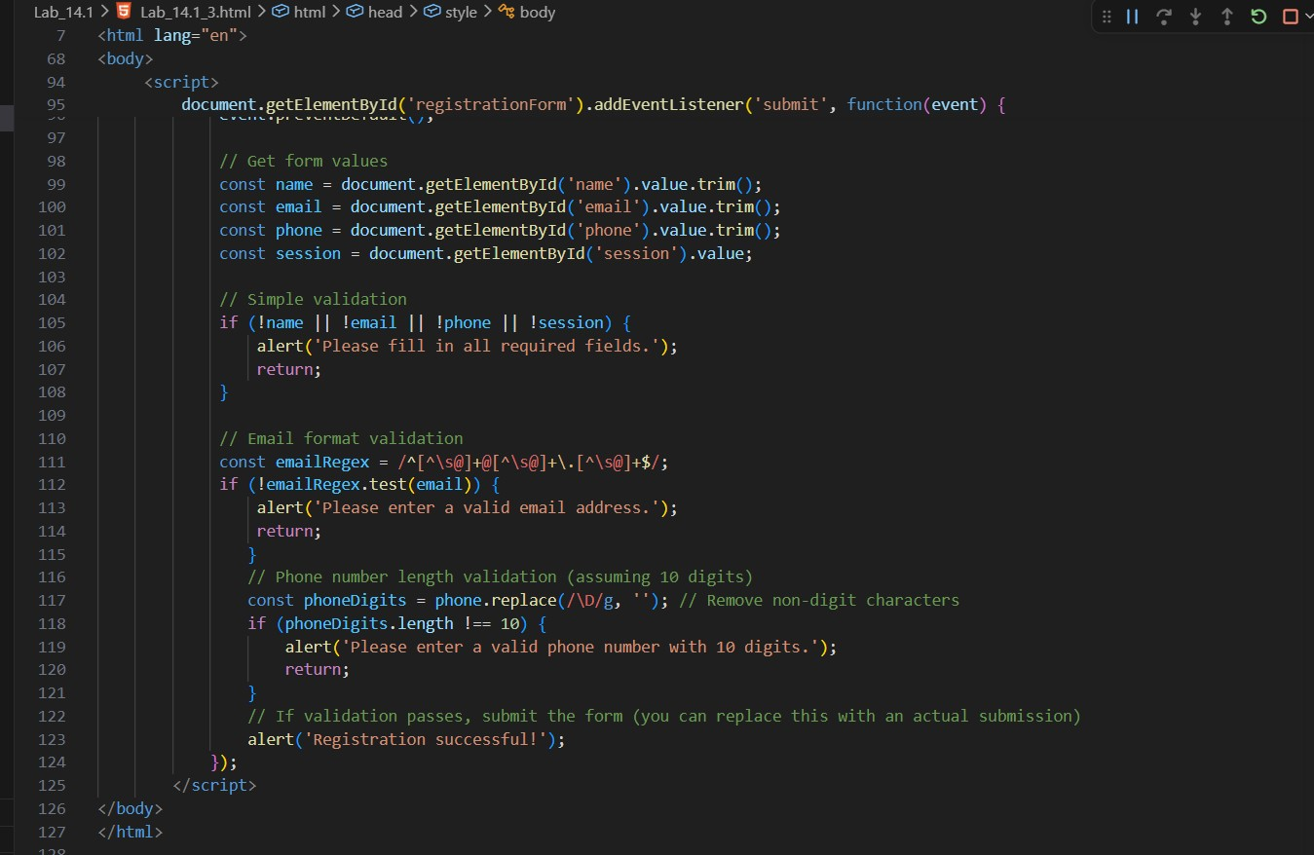
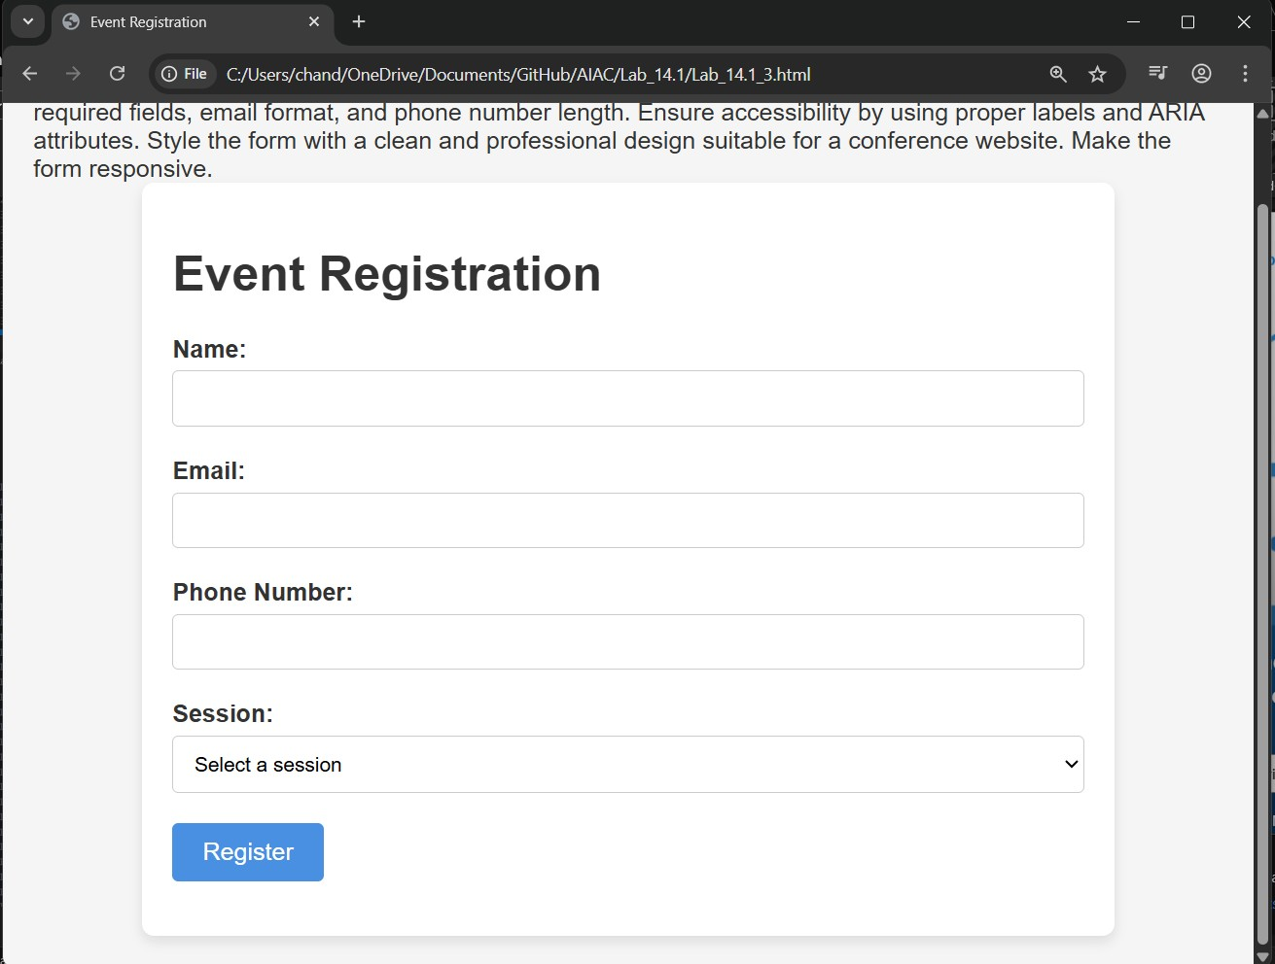

Task 4 – Resume Website
Build a one-page online resume.
Requirements:
- Sections: Profile Summary, Skills, Education, Experience.
- Use AI to:
- Propose professional typography styles.
- Align sections using CSS Grid. o Add smooth scroll navigation between sections.
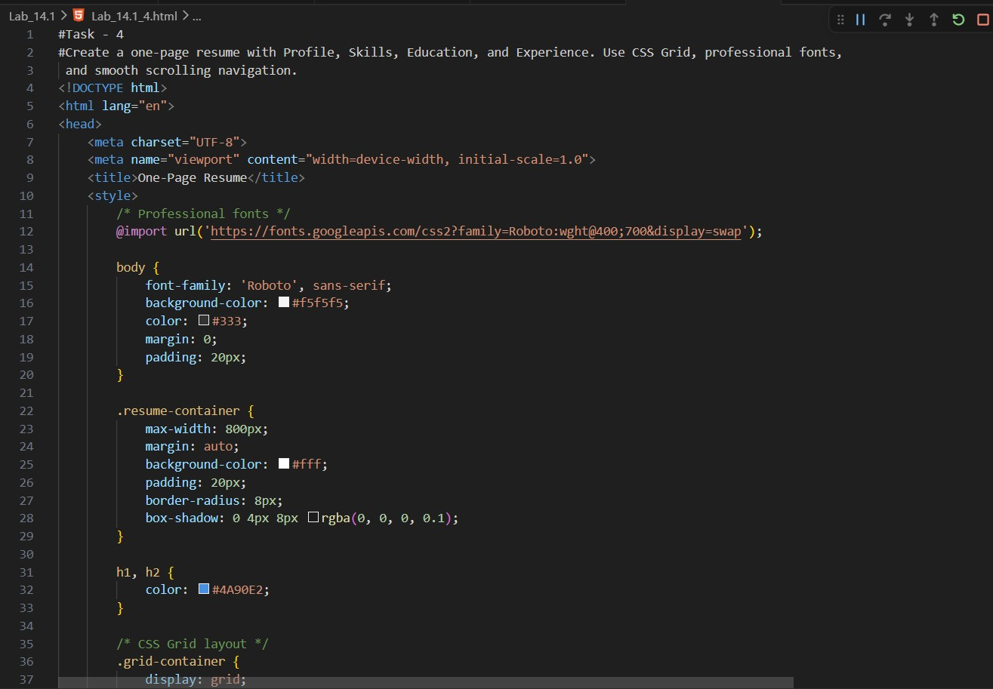
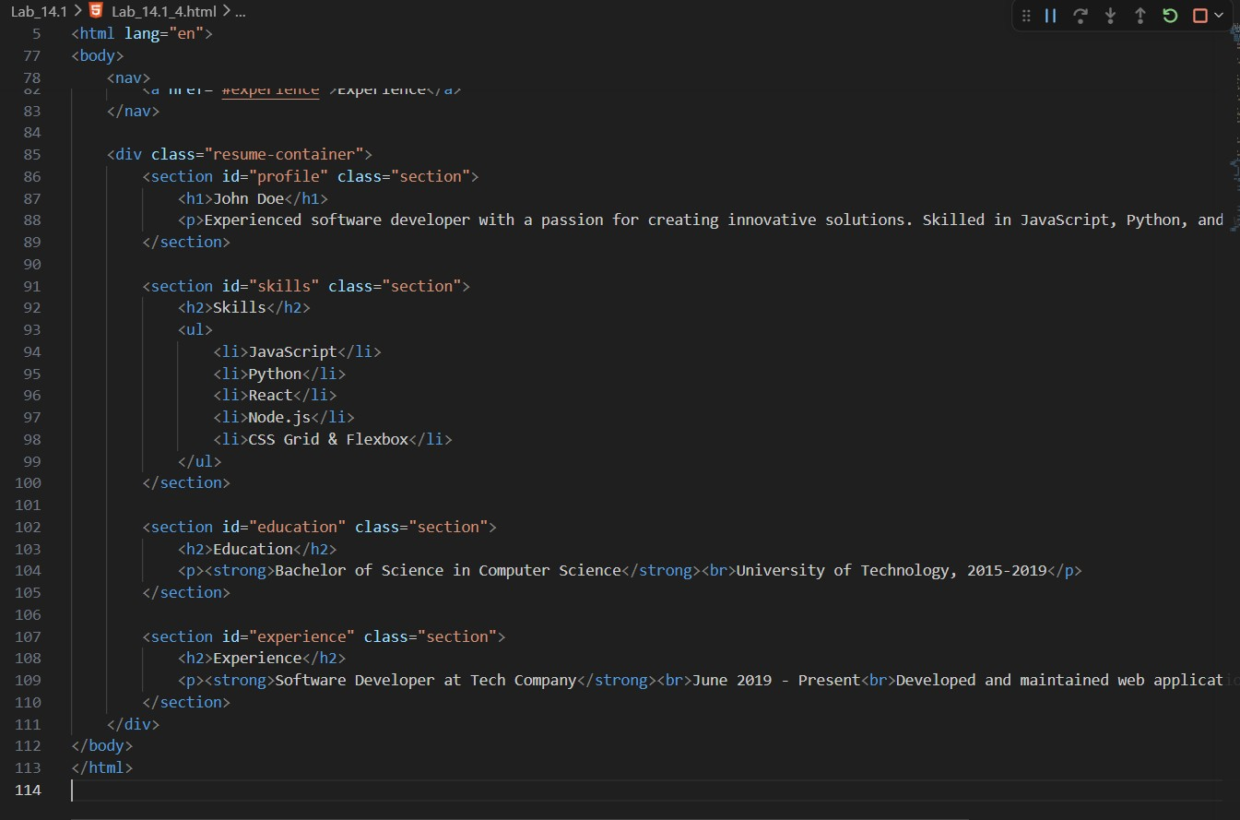
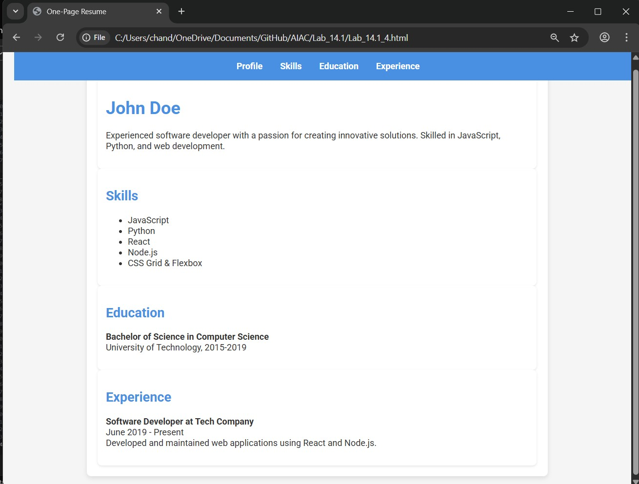

Task 5 – Restaurant Menu Page
Design a digital menu page for a restaurant.
Requirements:
- Display menu items with name, description, and price.
- Use AI to:
- Suggest a food-friendly color palette.
- Design a responsive card-based layout. o Add hover effects on menu items.
